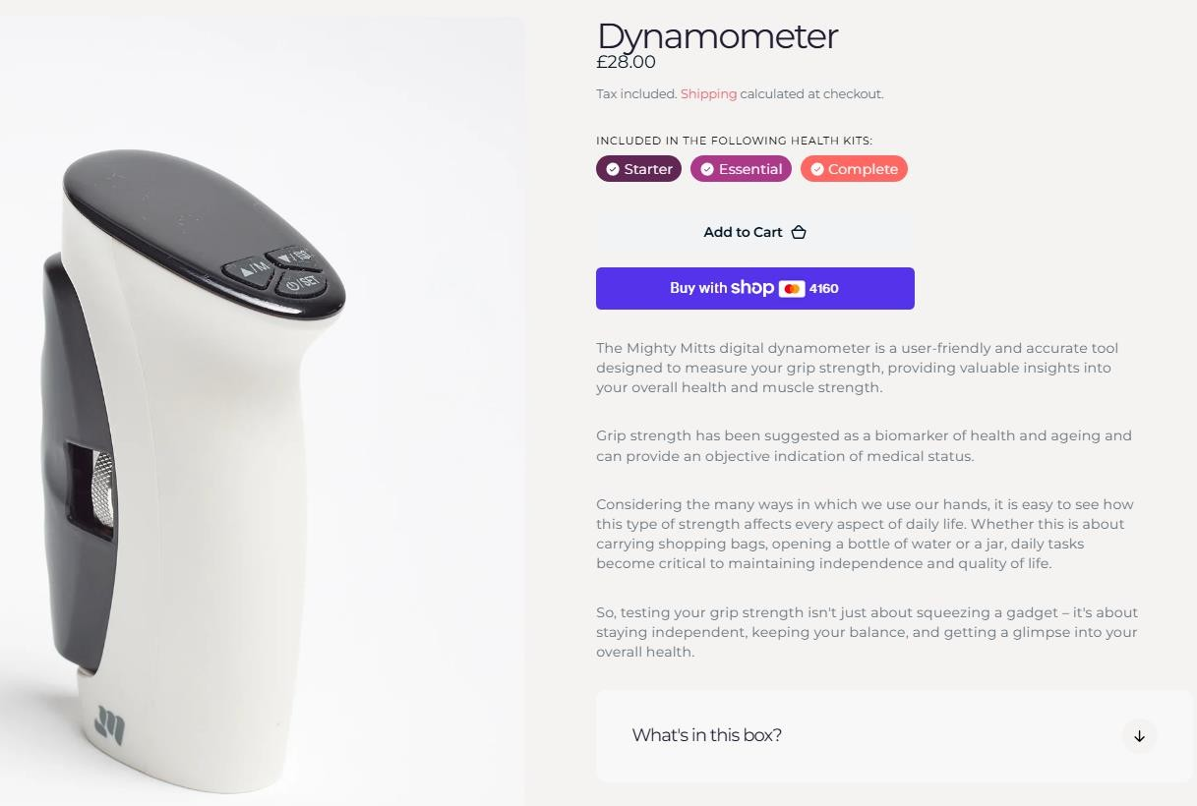
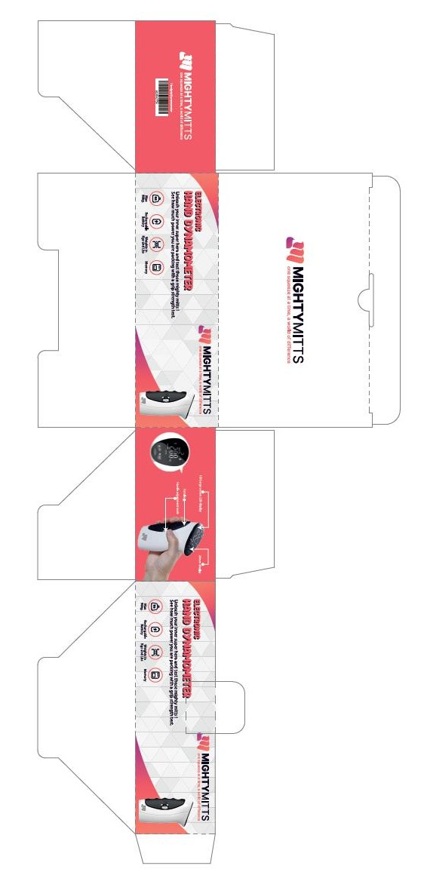

2,960pcs x Mighty Mitts Digital Hand Dynamometer Grip Strength Tester………RRP £28 Cost £2.30

